A CRM Application to Manage the Services offered by an Institution

**1.Create Objects from Spreadsheet:**

Configure the Case Object:

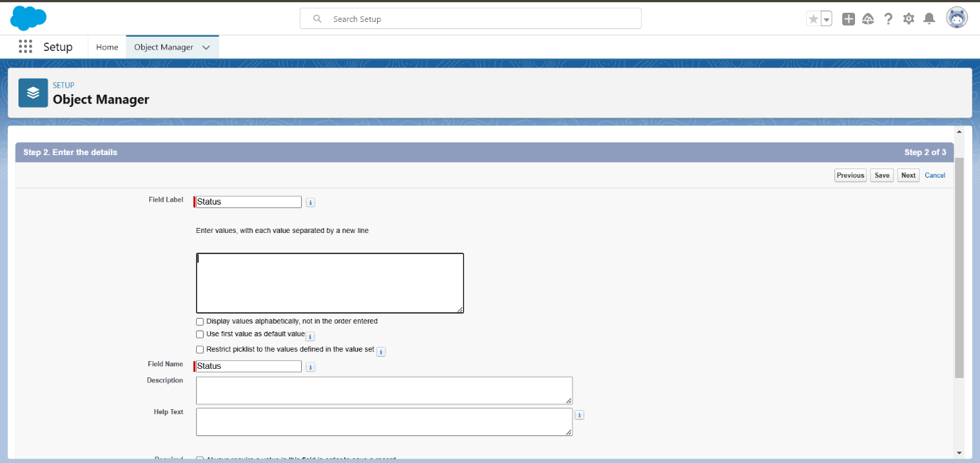**Create a Lightning App:**

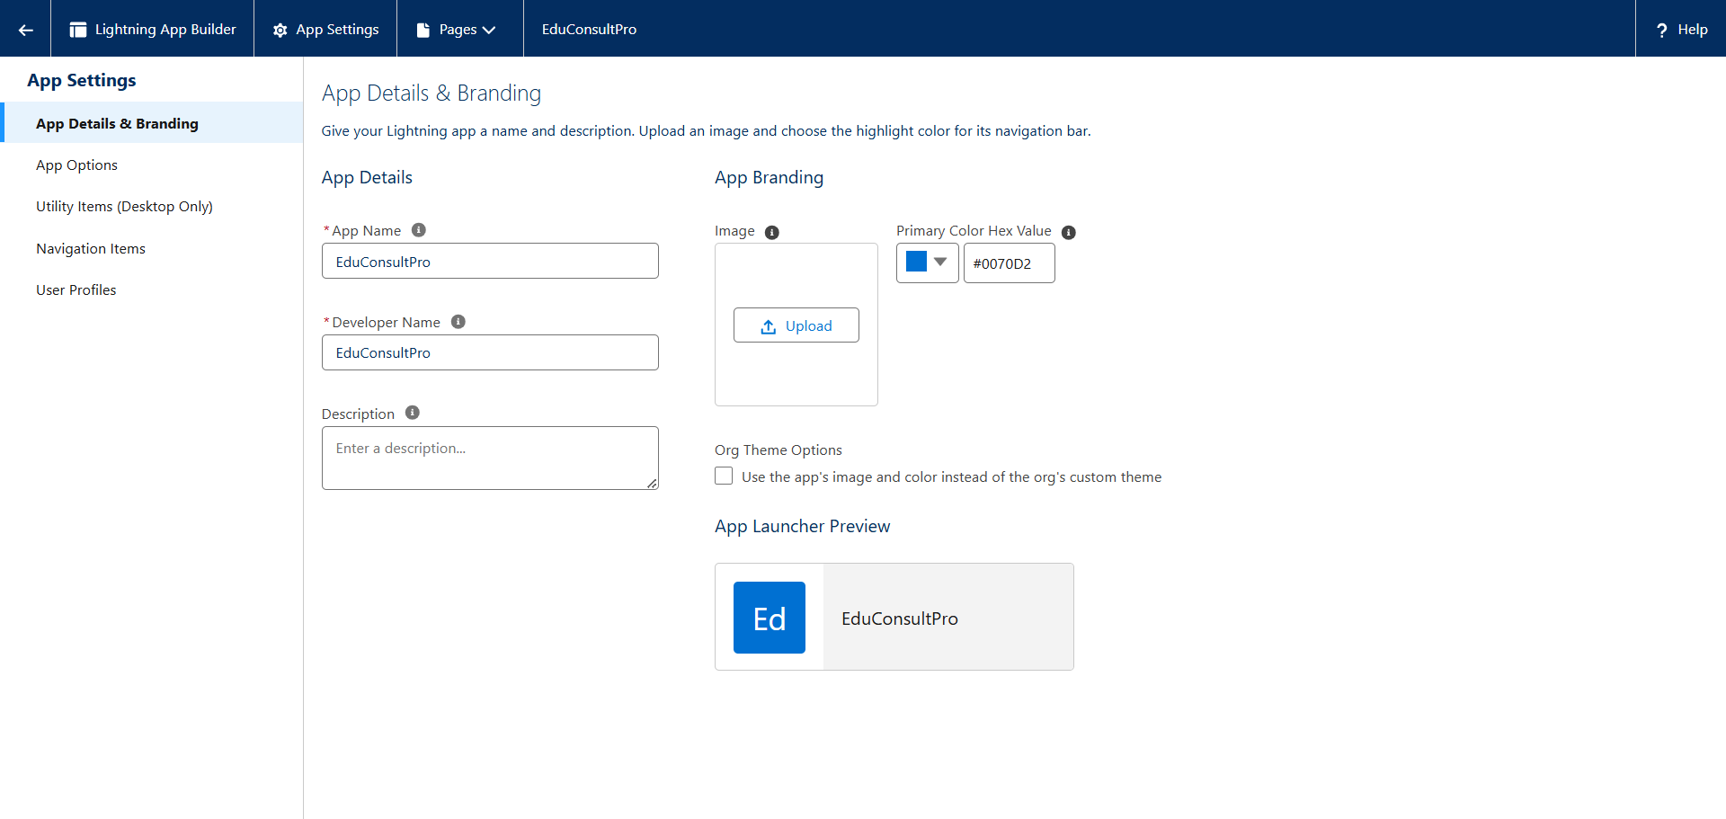

**2.Create a ScreenFlow for Student Admission Application process**:

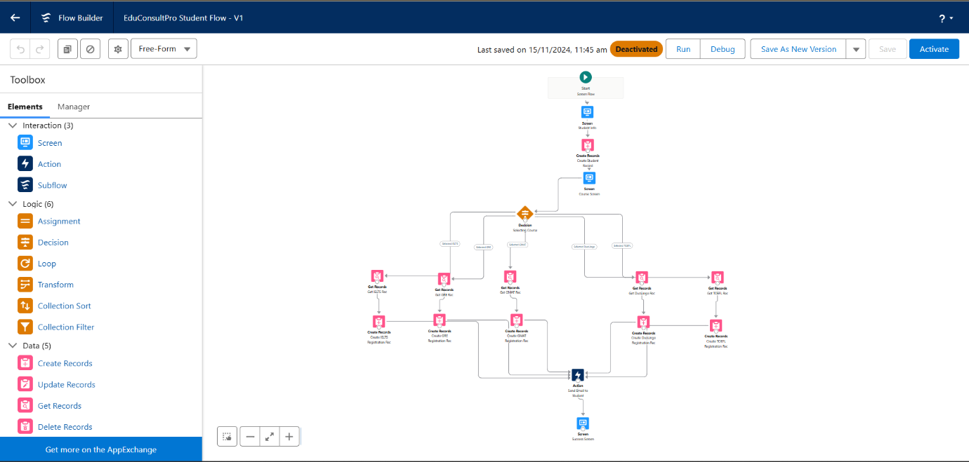

**3.Create Users:**

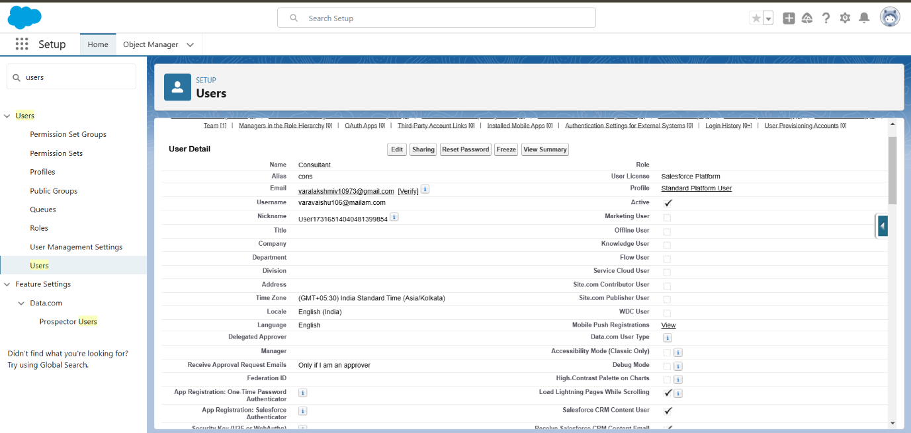

**4.Create an Approval Process for Property Object:**

Submission Template:

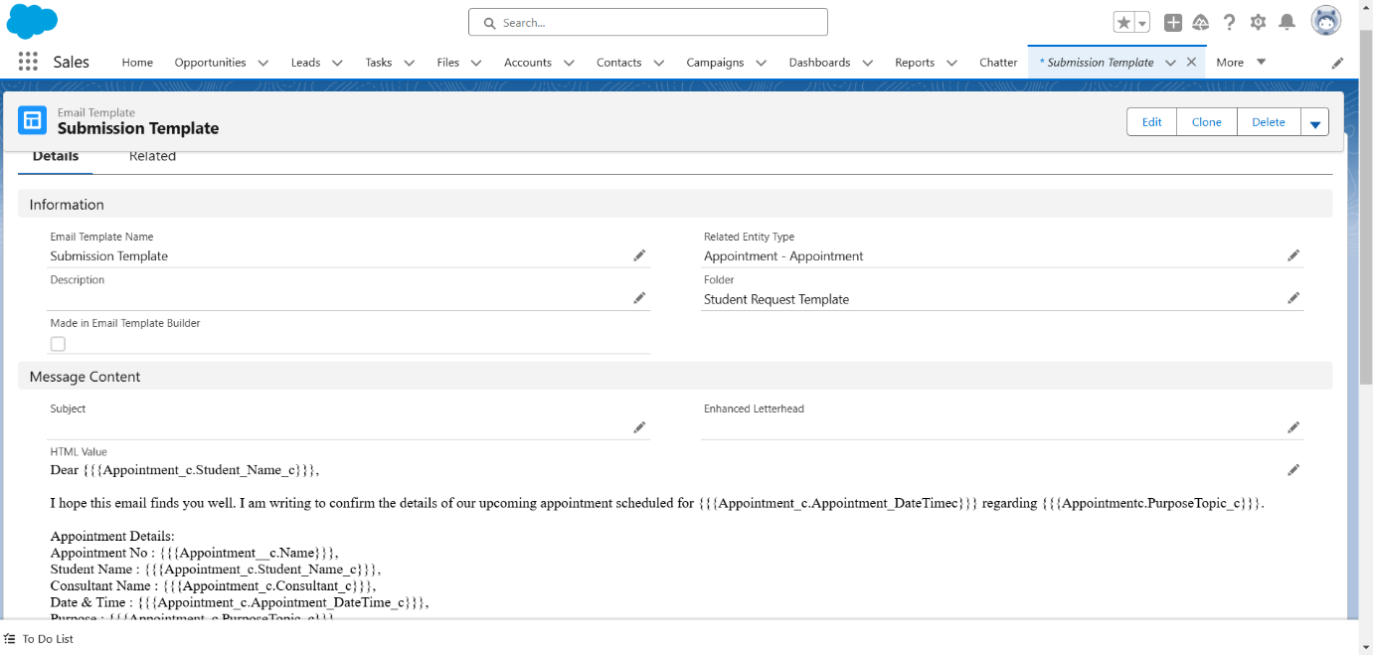

Rejection Template:

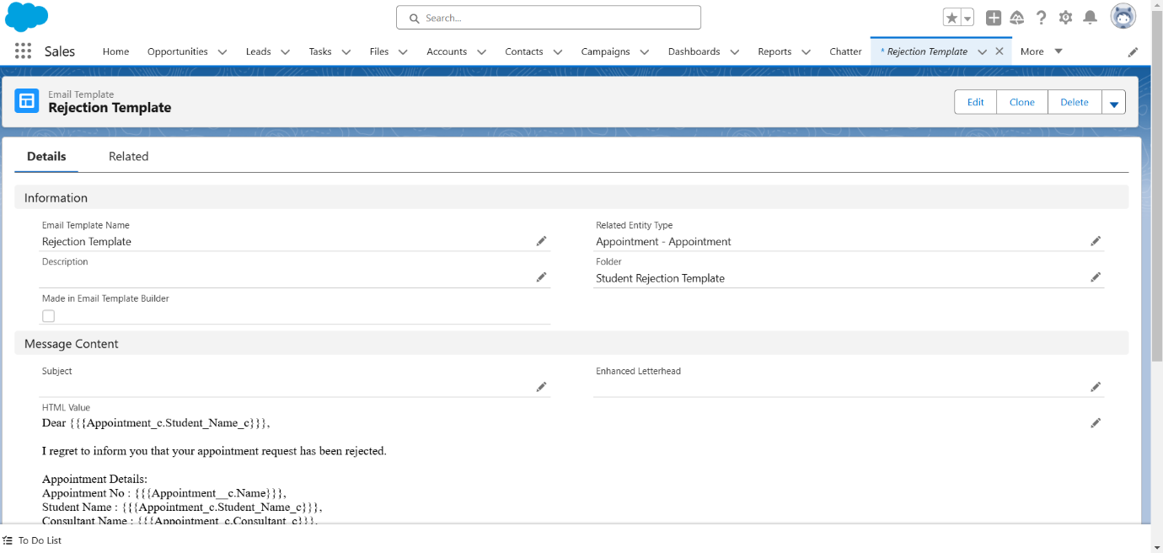

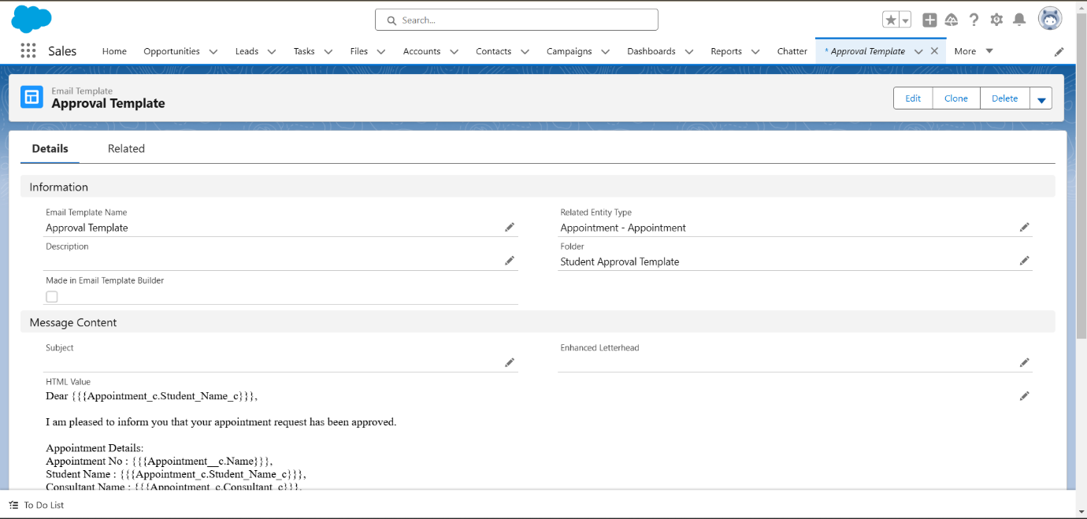 **Approval Template:**

**Create a Record Triggered Flow:**

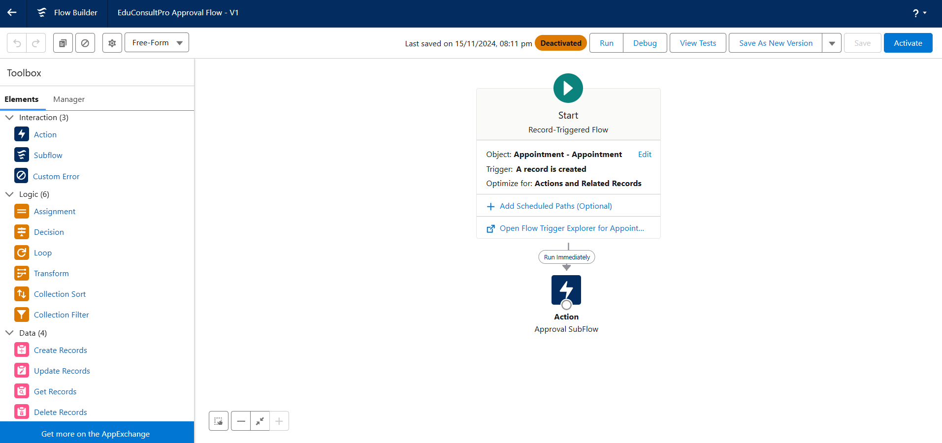

**6.Create a ScreenFlow for Existing Student to Book an Appointment:**

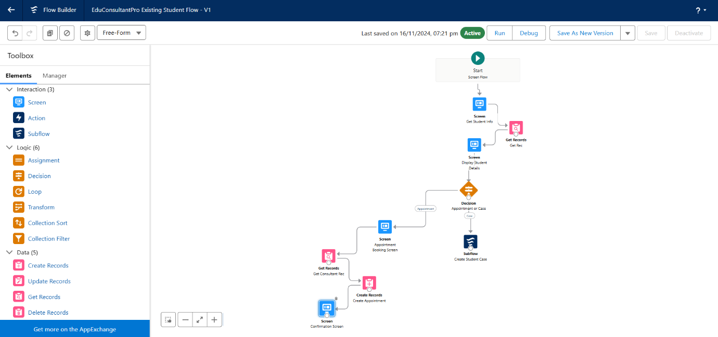

**7.Create a ScreenFlow to Combine all the flows at one place:**

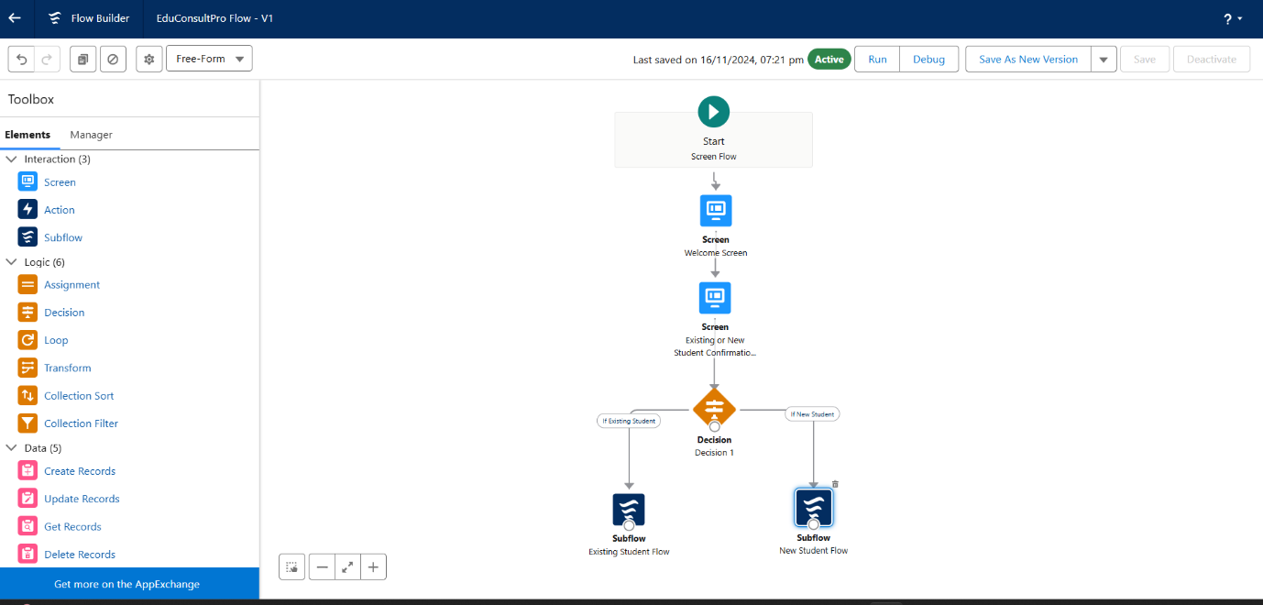

**8.Create a lightning app page:**

